TEK LED

VIBRATION SENSOR

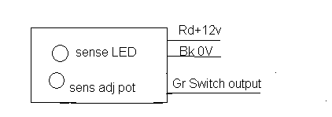
Sensor is mounted at the bottom of the unit. The unit should be fixed with the vibrating body firmly the sensitivity is adjusted for required vibration is detected the output goes low and the delay is provided for proper operation, vibrating frequency and amplitude can be detected.

Specification :

Supply : +12v dc , +2v Ripple free

Output current –PNP 100 ma
Delay 1 – 5 sec
Analogs o/p -10 ma

Address:
G.B . Kamala cannan , B.E
186/3, 20, Mathur Road,
Periykalapet ,
Pudhucherry-605014
Pony off: 0413-6547155
Mob: 94439-59337

